INS3121
SOIL MECHANICS
FINAL MAKE UP EXAM
January 19th, 2015
Student Name &Surname:
Q.1 | Q.2 | Q.3 | Q.4 | Q.5 | TOTAL
Number:
Group:

- Answer the following questions:
i- Explain the term cappilarity and its effect on effective stress.
ii- Explain the terms of overconsolidated clay and normally consolidated clay.
iii- Explain briefly how shear strength parametrs are obtained from a shear box test.
iv- Write down the factors affecting compaction in the field.
v- Plot the typical compaction curves obtained from standart proctor test and modified proctor test and show the compaction parameters obtained from these tests.

Name and Surname: Number: Group:
- An excavation will be opened in the soil profile shown in the below figure. The sand layer underlying the clay was observed to be under the artesian pressure. If the water in the drill hole rose to a height of 11 m above the sand layer.
  - How deep (H) can the excavation proceed before the bottom heaves?
  - Compute the factor of safety against heaving if the excavation reaches a depth of H=7m.
  - Compute the elevation head, pressure head and total head at the point of A by considering the top of sand layer as reference level.

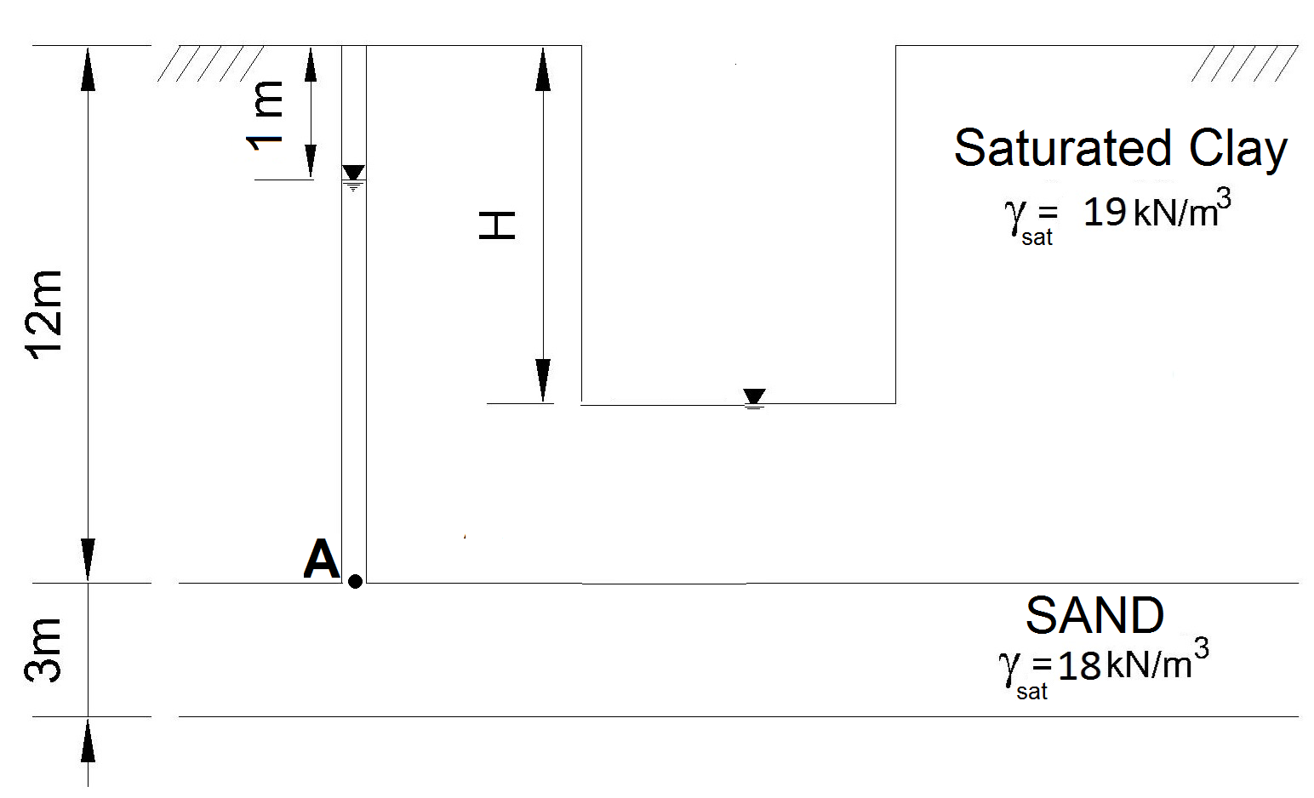

Name and Surname: Number: Group:

- The results of triaxial tests performed on disturbed and undisturbed clay soil samples are given in the below table:

Test | Cell Pressure (kPa) | Deviatoric Stress (kPa)
1.CD | 50 | 84.4
2.CD | 150 | 134
3. UU | 100 | 50

a) Compute the drained shear strength parameters of the clay soil.
b) Determine whether the soil is normally consolidated or overconsolidated clay according to the results obtained from the CD test.
c) Plot the Mohr Circle and failure envelope for the UU test at failure and determine the undrained shear strength parameters of the soil.

Name and Surname: Number: Group:

- An oil storage tank with a diameter of 35 and 15 m height will be constructed on the soil profile in the below figure.

a) If the preconsolidation pressure (σʹ_{p}) of the clay layer is 195 kPa, compute the settlement that will take place underneath the center of the tank due to primary consolidation of the clay layer.
- An oedometer test was performed on a clay sample recovered from the clay layer and coefficient of consolidation c_{v} is obtained to be 0.04865 cm²/min. Compute the settlement that will take place after 9 years.
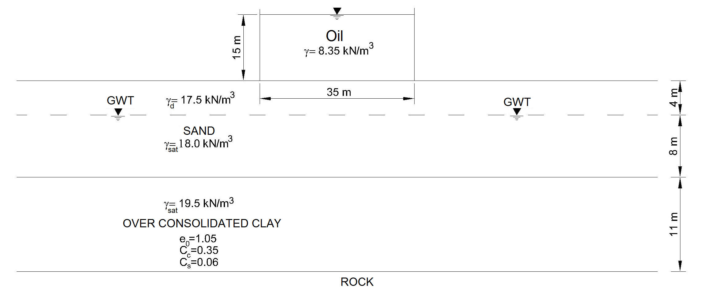
U (%) | 10 | 20 | 30 | 40 | 50 | 60 | 70 | 80 | 90
T_{v} | 0.008 | 0.031 | 0.071 | 0.126 | 0.197 | 0.287 | 0.408 | 0.567 | 0.848

Name and Surname: Number: Group:
- An earthfill will be constructed from a sandy silt soil that has a void ratio (e) of 0.80. The results of standart compaction test showed that maximum dry unit weight (γ_{kmax}) and optimum water content (w_{opt}) values are 17.5 kN/m³ and % 17, respectively. The specific gravity (G_{s}) of soil grains is determined to be 2.75:
  - The water content (w) and natural unit weight (γ_{n}) of the constructed earthfill is 16% and 19.5 kN/m³, respectively. Compute the volume of the soil that needs to be excavated from the borrow area to produce 40000 m³ compacted earthfill. Check if the compaction in the field meets 95% relative compaction and w_{opt} ±2% criteria.
  - If the natural water content at the borrow area is 18% and if there has been a 20% loss of water during transportation, determine if there is a need of addition of water during the construction of the earthfill.

Group 3: Dr. M. Ergenekon SELÇUK
Group 4: Asoc. Prof. Dr.Pelin ÖZENER
Group 7: Assist. Prof. Nejat N. ÇETİNKAYA
Group 8: Assist. Prof. Dr. Doğan ÇETİN

Exam time is 90 minutes. Good luck…

